A Project Report on

Tours And Travels

Name : Maruti Desai

Type of Project : Web Technology

Languages used : HTML5,CSS, Javascript & Bootsrap5

Date of Submission : 21-02-2025

**Overview:**

This travel website is designed to provide users with a seamless and interactive experience to explore travel destinations, book their trips, and access various services related to travel. The website uses modern web technologies like Bootstrap for responsiveness, Font Awesome for icons, and Google Fonts for an aesthetically pleasing text appearance. The website is structured into several key sections, each focused on different aspects of travel such as booking, packages, services, gallery, and an about section.

**Key Features:**

1. **Navbar:**
   * The website includes a **responsive navigation bar** powered by Bootstrap that adapts to different screen sizes. The navbar includes the website logo, a search bar, and links to important sections of the site: *Home*, *Book*, *Packages*, *Services*, *Gallery*, and *About*.
2. **Home Section:**
   * This is the landing section that introduces the website with a warm **welcome message** and a dynamic text area for changing destinations. It encourages users to **book a place** by providing a call-to-action button.
3. **Book Section:**
   * This section allows users to **book their travel plans** by filling out a form with details such as the destination, number of people, arrival and departure dates, and personal details. It ensures a simple and smooth booking process.
4. **Packages Section:**
   * **Travel packages** to popular destinations such as Goa, Mumbai, Bangalore, Varanasi, Delhi, and Chennai are presented here. Each package includes a description, a set of ratings (with stars), and a price, making it easy for users to compare options. The section provides a link to **book now** for each package.
5. **Services Section:**
   * The services section showcases the key services provided by the travel agency, including:
     + Affordable Hotels
     + Food and Drinks
     + Safety Guide

Travel Services like **Around the World**, **Fastest Travel**, and **Adventure Packages**

Each service is represented by an icon (from Font Awesome) and a brief description, making it easy for users to understand the offerings.

1. **Gallery Section:**
   * This section contains a **gallery** of images showcasing various travel destinations and experiences. It uses a grid layout to display images, helping users visualize the travel spots and potential experiences.
2. **About Section:**

several key sections, each focused on different aspects of travel such as booking, packages, services, gallery, and an about section.

**Key Features:**

1. **Navbar:**
   * The website includes a **responsive navigation bar** powered by Bootstrap that adapts to different screen sizes. The navbar includes the website logo, a search bar, and links to important sections of the site: *Home*, *Book*, *Packages*, *Services*, *Gallery*, and *About*.
2. **Home Section:**
   * This is the landing section that introduces the website with a warm **welcome message** and a dynamic text area for changing destinations. It encourages users to **book a place** by providing a call-to-action button.
3. **Book Section:**
   * This section allows users to **book their travel plans** by filling out a form with details such as the destination, number of people, arrival and departure dates, and personal details. It ensures a simple and smooth booking process.
4. **Packages Section:**
   * **Travel packages** to popular destinations such as Goa, Mumbai, Bangalore, Varanasi, Delhi, and Chennai are presented here. Each package includes a description, a set of ratings (with stars), and a price, making it easy for users to compare options. The section provides a link to **book now** for each package.
5. **Services Section:**
   * The services section showcases the key services provided by the travel agency, including:
     + Affordable Hotels
     + Food and Drinks
     + Safety Guide

Travel Services like **Around the World**, **Fastest Travel**, and **Adventure Packages**

Each service is represented by an icon (from Font Awesome) and a brief description, making it easy for users to understand the offerings.

1. **Gallery Section:**
   * This section contains a **gallery** of images showcasing various travel destinations and experiences. It uses a grid layout to display images, helping users visualize the travel spots and potential experiences.
2. **About Section:**
   * The about section provides information about how the travel agency works, explaining the process and its offerings. It also includes a **call-to-action button** to encourage users to read more about the agency.
3. **Footer:**
   * The footer contains the **branding** (Travel logo), a short description about the agency, and **social media links** for connecting with users via Twitter, Facebook, Instagram, YouTube, and Pinterest.
   * The footer also credits the **website design** to "SA Coding" and provides a **copyright notice**.

**Technological Features:**

1. **Responsive Design:**
   * The website uses **Bootstrap 5** to ensure that the layout is mobile-friendly and responsive, adapting to various screen sizes.
2. **Modern UI/UX Elements:**
   * The use of **Google Fonts** (Roboto) gives the site a clean, modern, and readable appearance.
   * **Font Awesome Icons** provide intuitive visual cues for the services and sections (e.g., plane icon for travel services, hotel icon for accommodation services).
3. **User Interaction:**
   * The **search bar** in the navbar allows users to search for destinations or services.
   * The **interactive form** in the Book section enables users to make reservations with all necessary details.
   * **Hover effects** on buttons and cards enhance the user experience by providing visual feedback when interacting with the website.

**Conclusion:**

The travel website offers a **user-friendly, responsive, and visually appealing interface** for users to explore travel destinations, book trips, and access a variety of services. Its combination of attractive design elements, well-organized sections, and interactive features makes it a functional and efficient tool for travelers.

**Snapshot:**

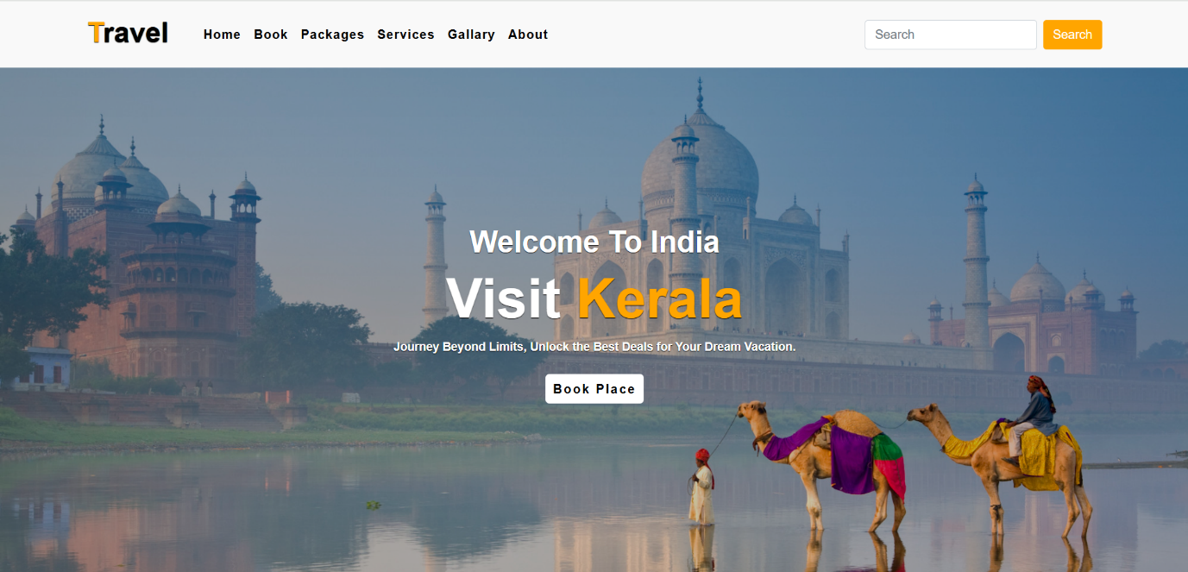

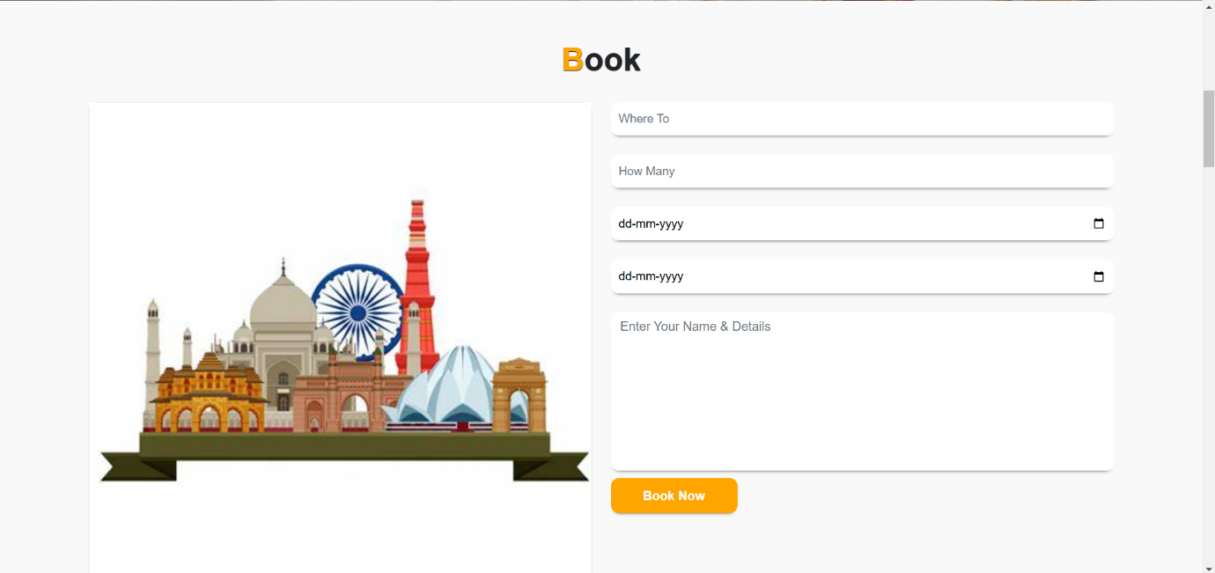

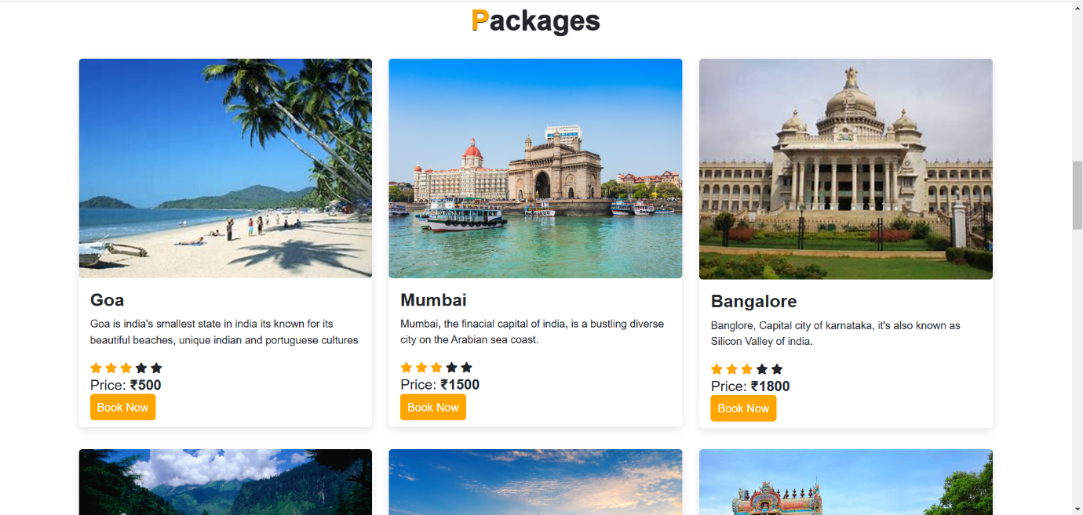

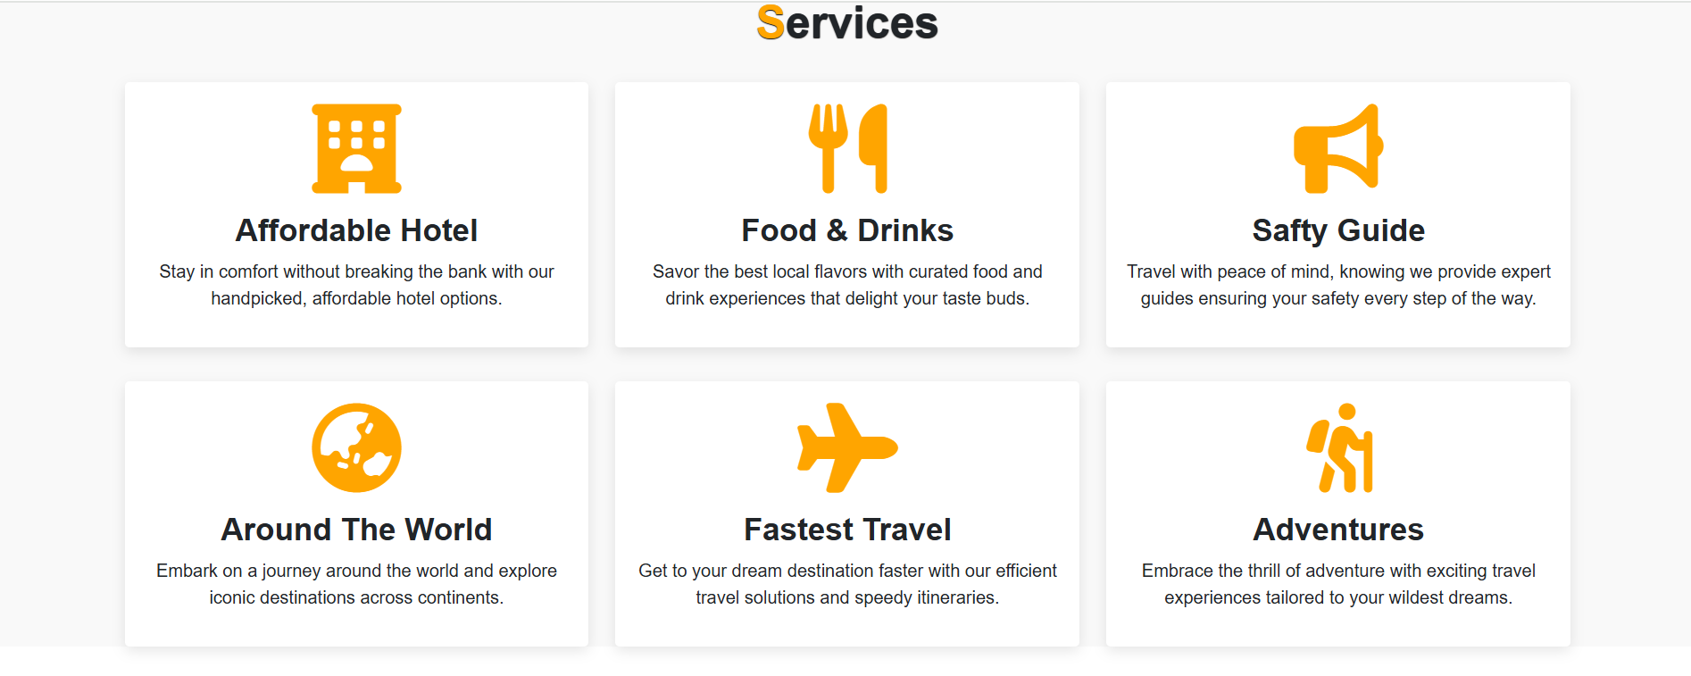

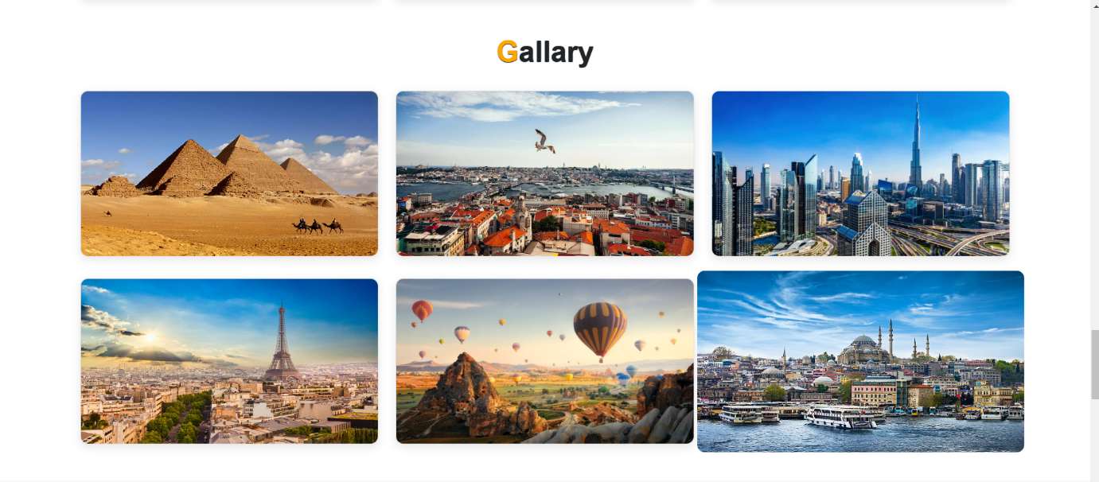

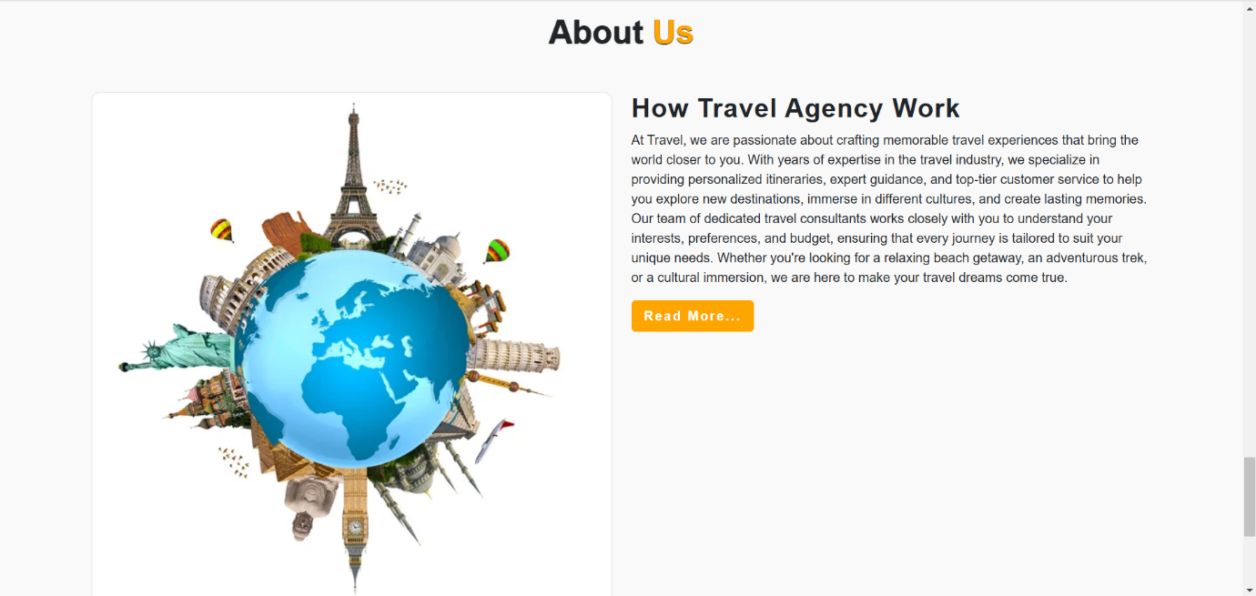

Thank you !